Assignment 2: Node.js Express.js

**Name:** Maryam Rashid

**Class:** BSCS-7A

**Reg no**. 215511

**Subject:** Advance Programming

**Explanation of output:**

Upon using the url <http://localhost:8000/index>, a form with two radio buttons opens up, namely seller and buyer. A buyer will click on “buyer” to view all the products available that belong to all the sellers. A seller will click on “seller” to login or sign up to his account.

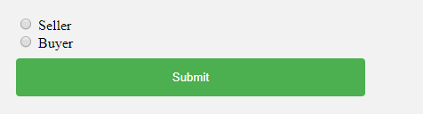

Let’s first consider a scenario where the user clicked on seller. After clicking Submit, a login signup page opens up. This includes two forms:

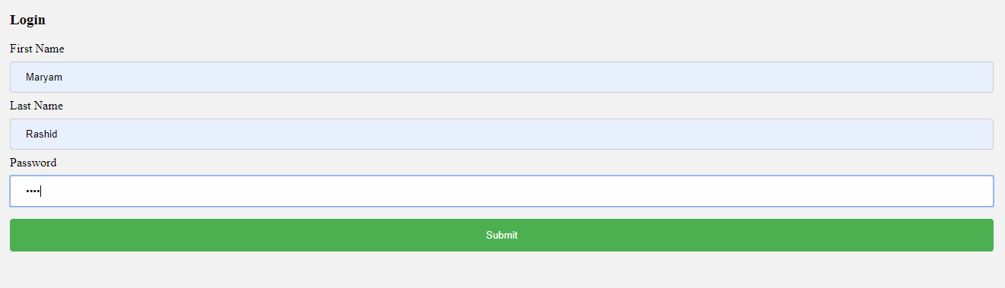

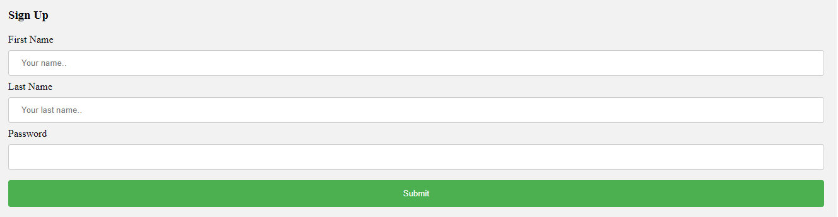

If the user already has an account he will simply login. In case of incorrect password or username an error message will be displayed. If he doesn’t have an account he would have to sign up. After successful login/sign up the products list will appear. This list includes only the products that belong to the seller who logged in.

For example if seller A would receive the following output:

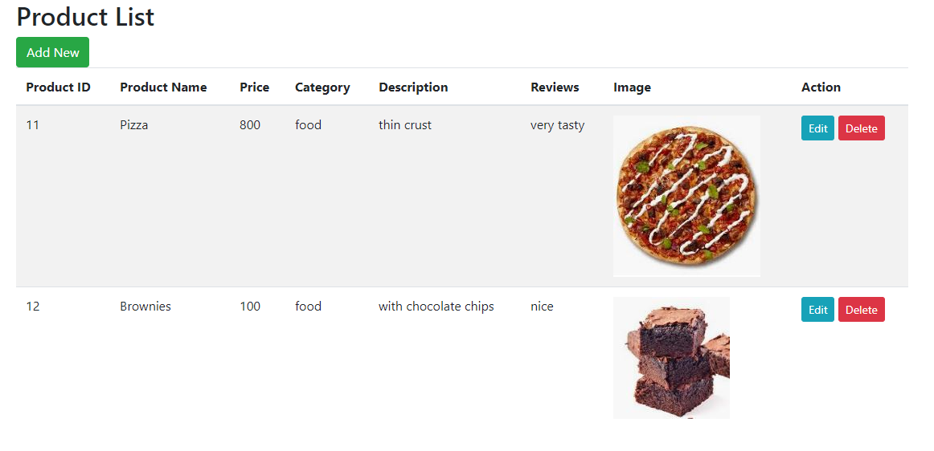

And seller B would get the output:

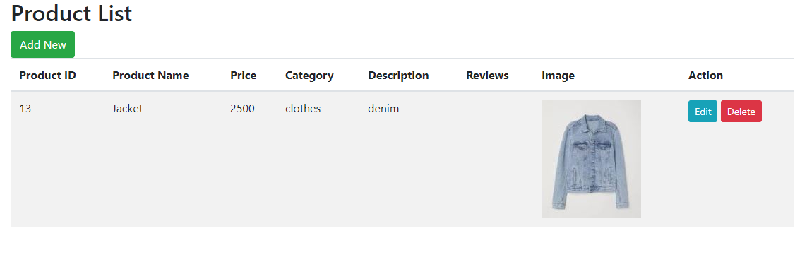

Each seller can add a new product, update an existing product, or delete a product.

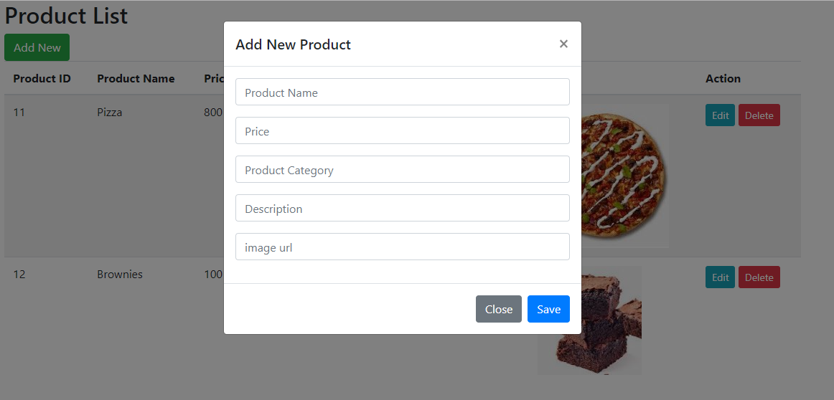

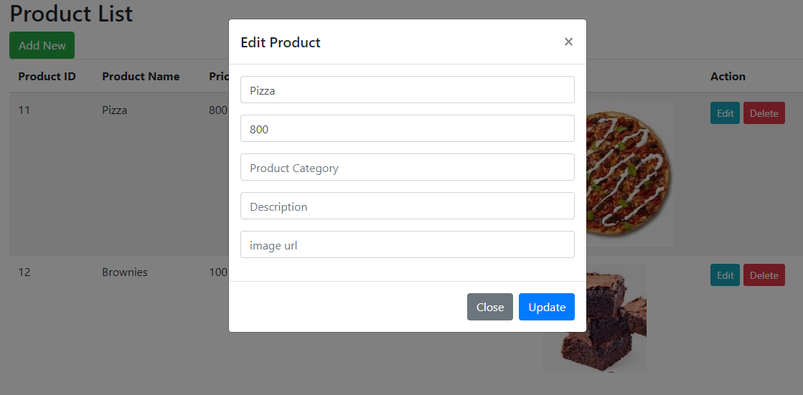

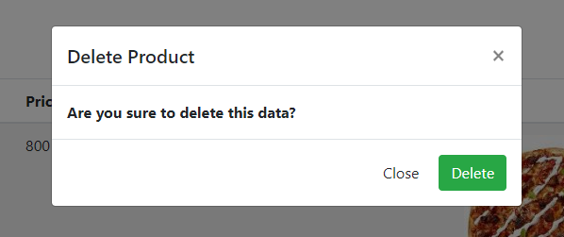

Now let us consider a scenario where the user clicked on “buyer” instead of “seller”. The user now can view all the products that belong to all the sellers. He cannot modify a product or delete it or add a new product. He can simply view it and add his reviews.

The output the buyer receives looks like this:

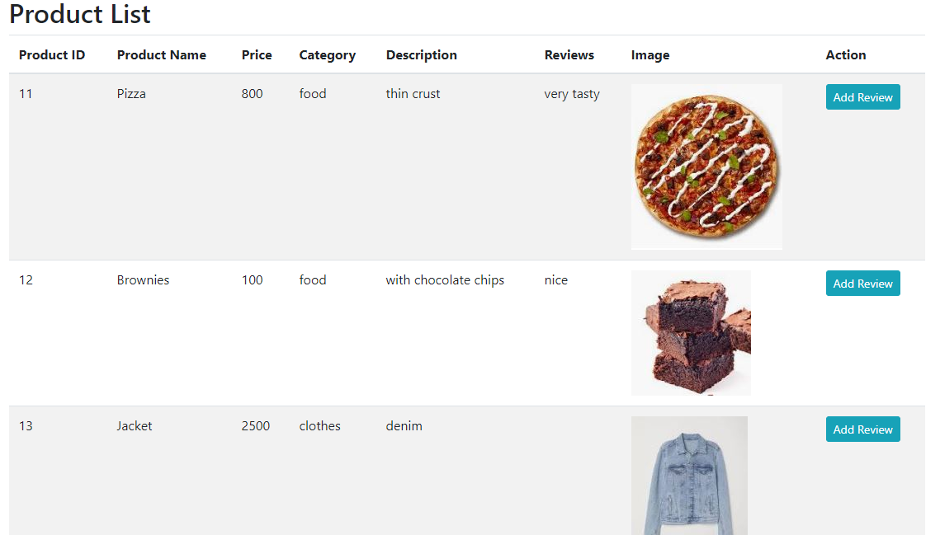

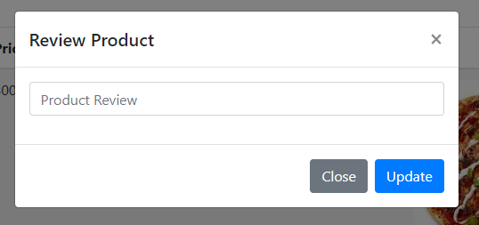

**Explanation of Database:**

This code makes use of two tables existing in a database. The tables are called product and users. The product table includes the following columns:

Product id, name, price, category, description, reviews, image, user first name, user last name, user password.

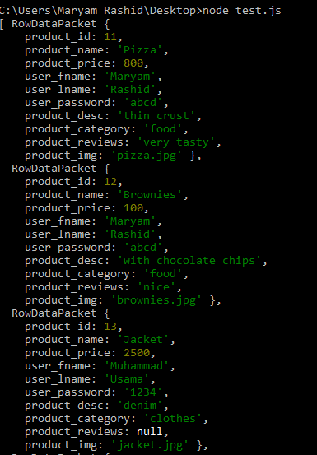

The users table contains the following columns:

Id, first name, last name, password.

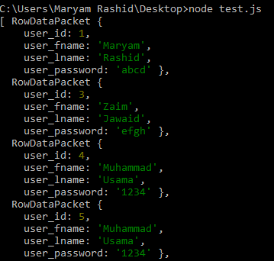

**Explanation of code:**

The node.js code exists in assignment.js file. It renders hbs files, namely products_view.hbs, products.hbs, index.hbs and index2.hbs.

**Index.hbs** contains buyer seller radio buttons.

**Index2.hbs** contains login sign up html page.

**Products.hbs** contains the html output that the buyer would see.

**Products_view.hbs** contains the html output that the seller would see. A seller would only be able to see his own products.

**Assignment.js** file contains the main code. It renders all the hbs files, runs appropriate sql commands and makes use of sessions to ensure privacy among various sellers.